How to Stop My Accidents

My name is _______. [Insert child’s picture]

I am in kindergarten at [insert school name].
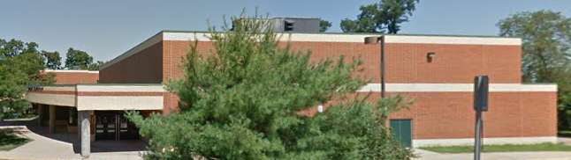
I work hard at school. I like school!

Sometimes I have to go to the bathroom. I know how to go to the bathroom. I learned when I was a little boy.
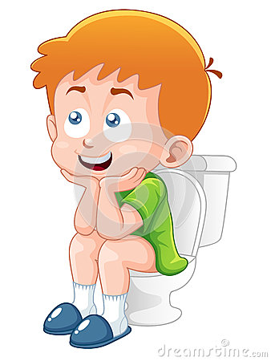
I know how to go to the bathroom!

Sometimes, I forget to say, “Hey I need to go to the bathroom now.” Then I have an accident.

I don’t like to have accidents. That feels yucky! I don’t like to feel wet. I like to feel dry.

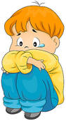
Oh no..I forgot to say “ I need to go to the bathroom.”

When I need to go to the bathroom I’m going to raise my hand or just call out: “I need to use the bathroom now!”
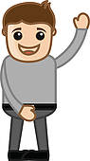
[insert teacher name] I need to use the bathroom!

If no one hears me I can just go by myself! I have a bathroom in my kindergarten room!
I can just walk there and use the bathroom!

[ Can insert a picture of student opening the BR door]
I can just go to the bathroom
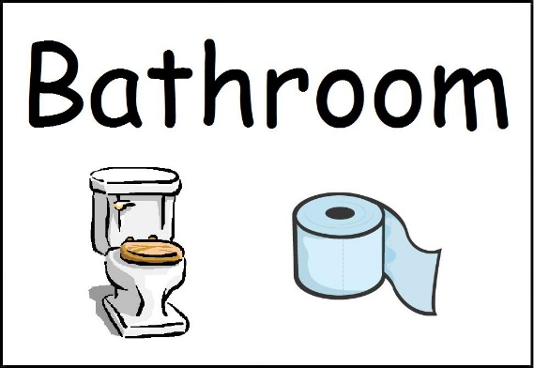
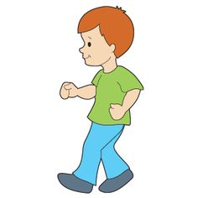

I’m so happy I can go to the bathroom and STAY DRY!
THAT FEELS GOOD!!!!
I’m dry!! Yea!
I went to the bathroom!

