How to Talk to My Friends

My name is __________ I go to ________Primary School.

Picture of student’s school here

I like the kids in my class. I have friends there too!

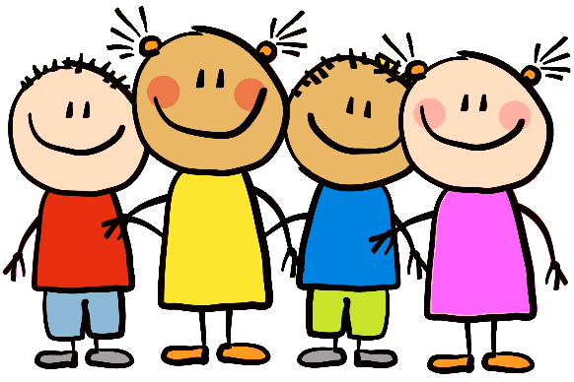

Sometimes I want to show something to my friend. Sometimes I want to say something to my friend.

When I want to talk to my friend I have to **LOOK at their face and SAY their name.**

Hi Anna!

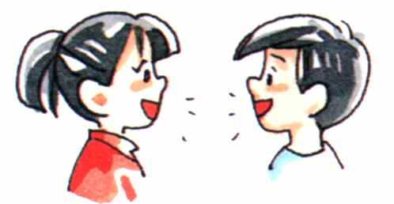

Sometimes I forget to talk to my friend the right way. Sometimes I touch them and have my tongue out. That is **not** a good way to talk to a friend.

My friends **DO NOT LIKE** that!

[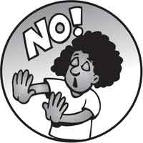](http://www.google.com/url?sa=i&rct=j&q=&esrc=s&source=images&cd=&cad=rja&uact=8&ved=0ahUKEwjw8qPli4bRAhWEQSYKHZdACacQjRwIBw&url=http://www.clipartkid.com/mom-saying-no-cliparts/&psig=AFQjCNHrIYxg_PT6dx-TxGyqA_CA0OlZtA&ust=1482437369048018)

**Don’t touch me! Just call my name. I will hear you.**

[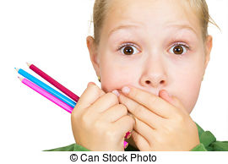](http://www.google.com/url?sa=i&rct=j&q=&esrc=s&source=images&cd=&cad=rja&uact=8&ved=0ahUKEwjJp-2JjobRAhXK7oMKHQkHBo0QjRwIBw&url=http://www.canstockphoto.com/images-photos/child-covering-mouth-hand.html&bvm=bv.142059868,d.amc&psig=AFQjCNGarHT0wN-onsu6hyBGAenhz0STPg&ust=1482437975901364)

So I will try to remember to

**KEEP MY TONGUE IN MY MOUTH**

I will try to remember to **KEEP MY HANDS TO MYSELF**!

[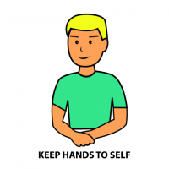](http://www.google.com/url?sa=i&rct=j&q=&esrc=s&source=images&cd=&cad=rja&uact=8&ved=0ahUKEwjW1u-oj4bRAhXh3YMKHbwQBzoQjRwIBw&url=http://www.clipartkid.com/keep-hands-and-feet-to-yourself-cliparts/&bvm=bv.142059868,d.amc&psig=AFQjCNHx0vengAvbOQ8m0lCPSb9uTZKKog&ust=1482438314295666)

I will try to **remember** to say my friend’s name

I will try to **remember** to look at them

**I’m saying my friend’s name and we are playing**

**I’m remembering to keep my hands to myself and look at my friend to talk**

[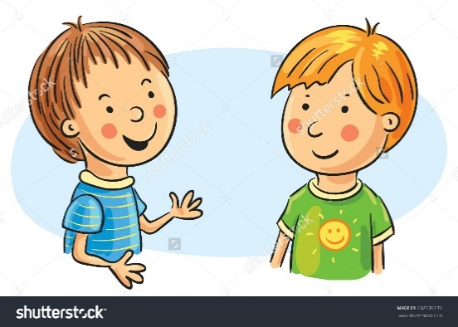](https://www.google.com/url?sa=i&rct=j&q=&esrc=s&source=images&cd=&cad=rja&uact=8&ved=0ahUKEwjC8ZnI84fRAhVCRiYKHbtmCqAQjRwIBw&url=https://www.clipartsgram.com/clipart-of-kids-talking-14429&psig=AFQjCNELep51OFLi45MmZI4JlpP_zXI2JQ&ust=1482499557646645)

[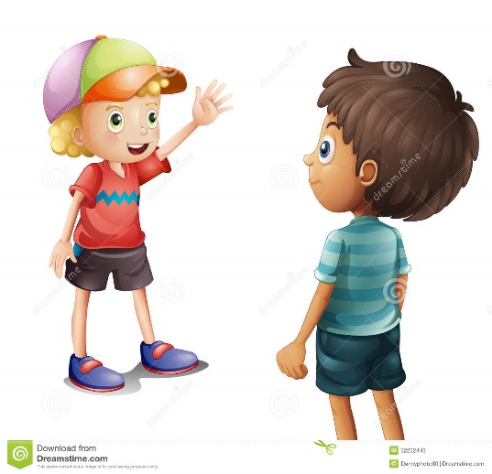](https://www.google.com/url?sa=i&rct=j&q=&esrc=s&source=images&cd=&cad=rja&uact=8&ved=0ahUKEwjGkuW99YfRAhXBRyYKHS4rBucQjRwIBw&url=https://www.dreamstime.com/stock-photos-boy-waving-his-friend-illustration-white-background-image32202443&bvm=bv.142059868,d.eWE&psig=AFQjCNEOvSa2ULB6Gh96llhOv10UIkH2Xw&ust=1482500072223382)[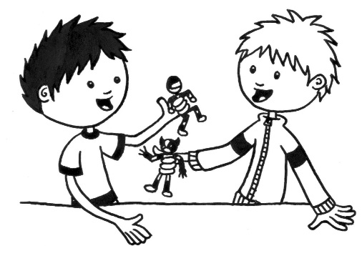](http://www.google.com/url?sa=i&rct=j&q=&esrc=s&source=images&cd=&cad=rja&uact=8&ved=0ahUKEwiqs8G29IfRAhWCMyYKHc1RAfEQjRwIBw&url=http://www.clipartkid.com/sharing-toys-cliparts/&bvm=bv.142059868,d.eWE&psig=AFQjCNHyuwCRYkyTyrwg8UoHpNGlLeO0HA&ust=1482499829043177)

**I’m remembering to say my friend’s name and look at him. (hands to self tongue in mouth)**

Hands are for waving ‘HI’ to my friends

Tongues are for ice cream and lollipops

[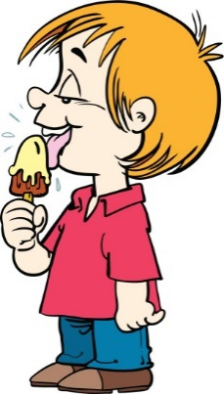](http://www.google.com/url?sa=i&rct=j&q=&esrc=s&source=images&cd=&cad=rja&uact=8&ved=0ahUKEwiwiNH9_ofRAhVJq48KHfMvAGcQjRwIBw&url=http://www.istockphoto.com/illustrations/silhouette-of-a-licking-ice-cream-cone&bvm=bv.142059868,d.eWE&psig=AFQjCNHNV4Kb0uHeigr1N3rEV45hRIFkNQ&ust=1482502674916122)[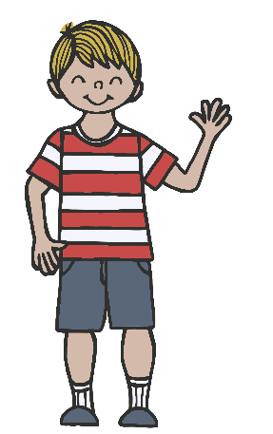](http://www.google.com/url?sa=i&rct=j&q=&esrc=s&source=images&cd=&cad=rja&uact=8&ved=0ahUKEwjXyYfw-4fRAhXHRiYKHVLrCYEQjRwIBw&url=http://www.clipartkid.com/bye-cliparts/&bvm=bv.142059868,d.eWE&psig=AFQjCNG2skpjJI2bEl_7RXgi-Zy7FG7-mA&ust=1482501840639525)

[](https://www.google.com/url?sa=i&rct=j&q=&esrc=s&source=images&cd=&cad=rja&uact=8&ved=0ahUKEwiaurz2-IfRAhUEySYKHRFJAY4QjRwIBw&url=https://www.pinterest.com/pin/533535887078916261/&bvm=bv.142059868,d.eWE&psig=AFQjCNGL6CGWWMzdxbpfVMxLmLe2Hcz45Q&ust=1482501003363069)Do you know who remembers things? AN ELEPHANT! Elephants remember to look at their friends. They remember tongues are for ice cream **NOT** for kids.

[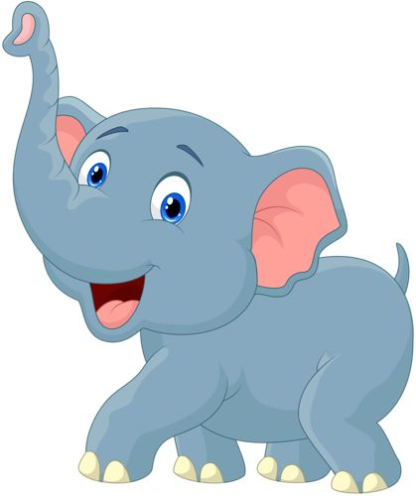](https://www.google.com/url?sa=i&rct=j&q=&esrc=s&source=images&cd=&cad=rja&uact=8&ved=0ahUKEwi3wtGb-ofRAhVIQCYKHbYYB1UQjRwIBw&url=https://au.pinterest.com/explore/cartoon-elephant/&bvm=bv.142059868,d.eWE&psig=AFQjCNE1jmvRpWDIYNM7e5PVT3-yczSUiw&ust=1482501374494802)They remember to use their trunk to wave ‘HI’.

[Child’s name] if you remember to

* Look at your friend and say their name
* Use your hand to wave
* Keep tongue in mouth
* Keep hands to self

[](https://www.google.com/url?sa=i&rct=j&q=&esrc=s&source=images&cd=&cad=rja&uact=8&ved=0ahUKEwjBnNHe-ofRAhWC4CYKHdXlBWIQjRwIBw&url=https://www.pinterest.com/pin/399201954450703513/&bvm=bv.142059868,d.eWE&psig=AFQjCNE1jmvRpWDIYNM7e5PVT3-yczSUiw&ust=1482501374494802)Then [Teacher’s name] might give you a picture of me!! !!

**YEA [child name] YOU REMEMBERED !!**