I Need to Remember!
I go to ______ Elementary School. Sometimes I ask to use the bathroom. My teachers usually say ‘yes.’
I know how to use the bathroom. I am a big girl now. I’m actually in 4th grade!
I know how to pull down my pants.
I know how to go on the toilet.
I know when I’m finished to wipe and flush.
Most important, I know when I am finished to pull up my pants then wash my hands.
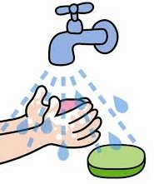
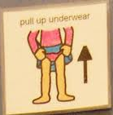

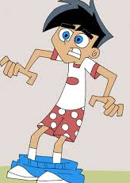
I know to never walk out of the bathroom with my pants down.
Oh no! I forgot to pull up my pants! I have to go back and pull them up.

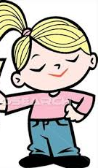
ALWAYS walk out with my pants up!
I remembered to pull up my pants!
If I remember my teachers will be
happy and I will be proud of myself!

