

My name is ______. I am preschooler. I have hair and eyes.



I have a face, two arms, two legs,

two feet,

two feet

[](http://www.google.com/url?sa=i&source=images&cd=&docid=8gedH6Q6pkZsZM&tbnid=PaWlI3BuIA7J5M:&ved=0CAgQjRwwAA&url=http://health.howstuffworks.com/skin-care/information/anatomy/question514.htm&ei=gR19UufPF7al4AP-woCACA&psig=AFQjCNEDUfCqBmmQw2Z0JG1h3lScEn9vnQ&ust=1384017665416496)

[](http://www.google.com/url?sa=i&rct=j&q=&esrc=s&frm=1&source=images&cd=&cad=rja&docid=KK0rOGqbztKm3M&tbnid=cpu0AGTBrZQOzM:&ved=0CAUQjRw&url=http://commons.wikimedia.org/wiki/File:071228_human_hands.JPG&ei=3Rx9UqehBtLk4AOL24DwDA&bvm=bv.56146854,d.dmg&psig=AFQjCNFGylU_3IwLihMRffpNjE1hcExIOA&ust=1384017449208204)two hands

I have a body. Just like ______. Just like Mommy, Just like Daddy.



Just like my friends at school.



I use my hands allllllll the time.



I use my hands to clap. I use my hands to give high five. I use my hands to eat. I use my hands to play.





I use my hands to string beads and do puzzles

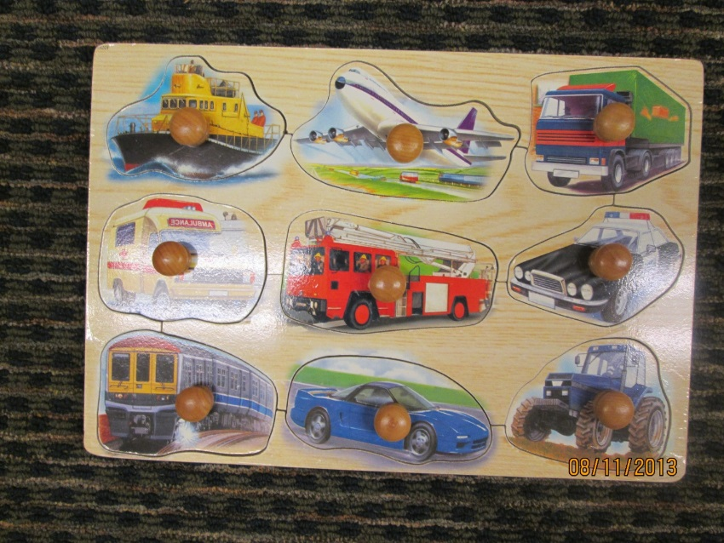

 At school my hands are for playing .

I use my hands to brush my hair, put on lotion.

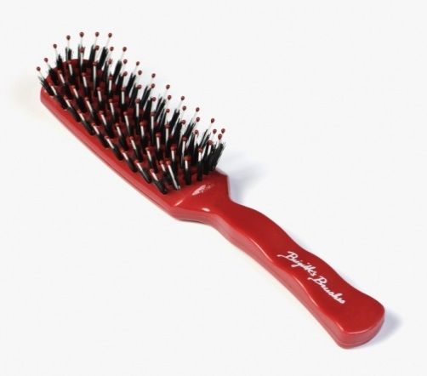

[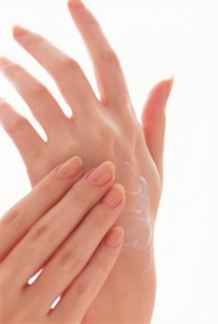](http://www.google.com/url?sa=i&source=images&cd=&docid=2kKuUXkgLAkgOM&tbnid=iPdcAQeBMnTgAM:&ved=0CAgQjRwwAA&url=http://www.raising-redheads.com/skin-care-tips.html&ei=2yJ9UsDVFtSu4AO7_4CQCg&psig=AFQjCNEECQl3lYqPIpF2mUrE0KIw3behfw&ust=1384019035409187)

When I go to the bathroom I sit on the potty and pee or poop, flush, wash my hands and that is all.

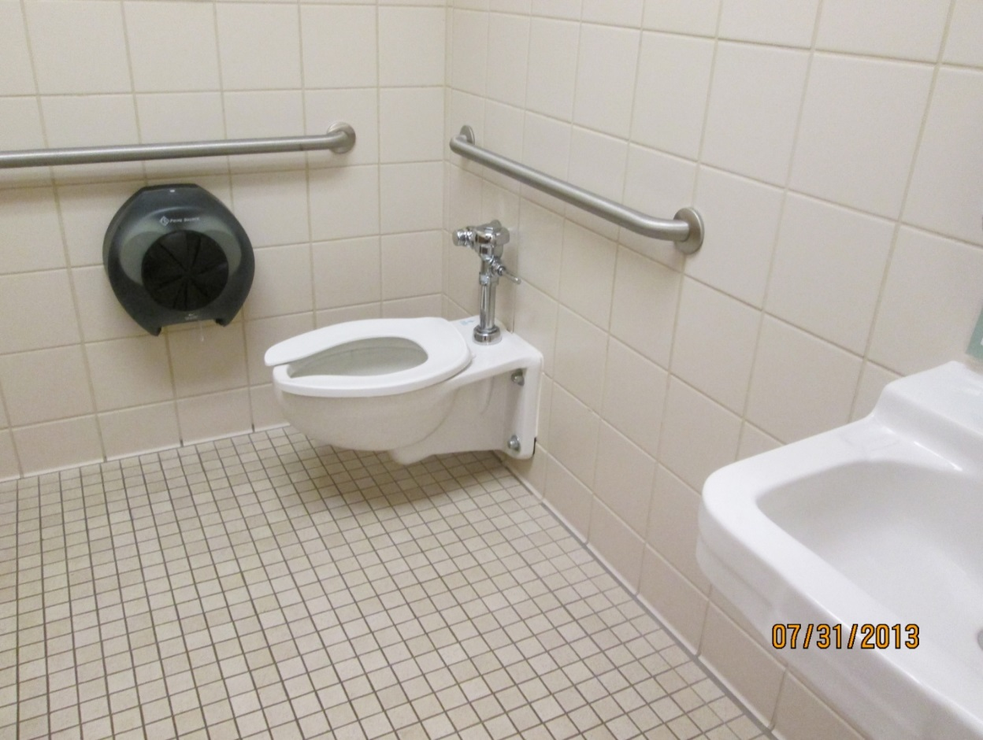

I keep my hands out of my pants.



On the bus - no hands in my pants.

[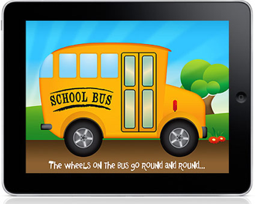](http://www.google.com/url?sa=i&source=images&cd=&docid=m_v0ygYETogmvM&tbnid=MnfAuZglxJOveM:&ved=0CAgQjRwwAA&url=http://www.cultofmac.com/108158/mobile-learning-school-lifts-ipad-ban-on-buses/&ei=ziR9UsmoOK3I4APRh4HQAQ&psig=AFQjCNHDkI7Ahug-PQG929ObRU3B6KD_GQ&ust=1384019534957783)

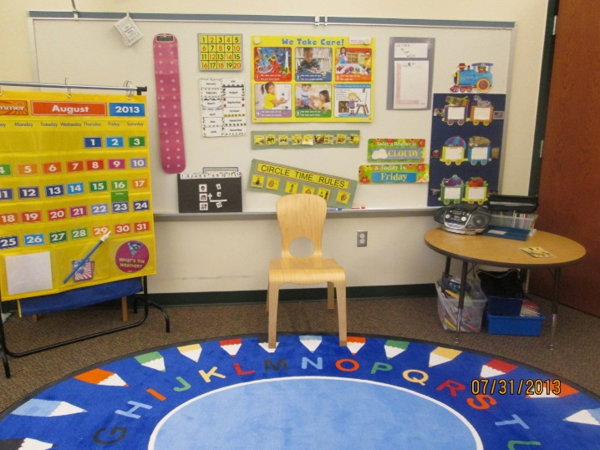In school – no hands in my pants.

On the playground – pants are on. No hands in my pants.

Yeah – I love my hands.



[](http://www.google.com/url?sa=i&source=images&cd=&cad=rja&docid=G6gVyfBA7pIRsM&tbnid=IGmkPunP25u3AM:&ved=0CAgQjRwwAA&url=http://www.annandale-umc.org/preschool-programs/weekday-preschool&ei=6SV9Upn1K5Gq4APj5oHoCg&psig=AFQjCNEsZyT2ouHlz9c1wacG8Xaap98cog&ust=1384019817755848)