Some Students
Work Fast
And
Some Students
Work Slow
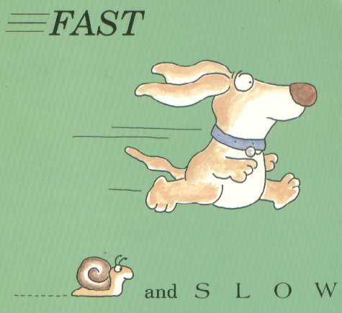
Kids go to school to learn new things.
Learning about new things is a fun thing to do.
Everyone thinks and learns differently.
Some kids work fast and some kids take more time and go slowly.
It is okay for kids to work fast or slow. Everyone’s brain is different, some are faster and some are slower.
The important part is that everyone’s brain is learning new things.

Some kids will finish their work before other kids.
Even if kids work a little slower and take a longer time to finish – they are still winners. They are winners because they are learning.
The kids that work fast and finish before everyone is done, have to wait. They can go on to do more work or they can read a book or draw until everyone is ready to move on. It is the teacher’s decision to tell you to wait or to keep working.

It is okay when everyone works at their own pace, because everyone works and learns differently.
The kids that work a little slower may have to finish their work later in the day or even during the next school day. That is okay.
That is the teacher’s decision. The teacher will tell the kids to keep working or to wait and finish later.
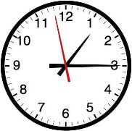

Try to remember, that the most important thing is that kids learn. It does NOT matter how long it takes to learn. When you are learning you are a winner.

Fast or Slow, Now or Later,
Take Your Time and It Will Make You Greater!!

Take some deep breaths and stay calm so your brain will keep growing

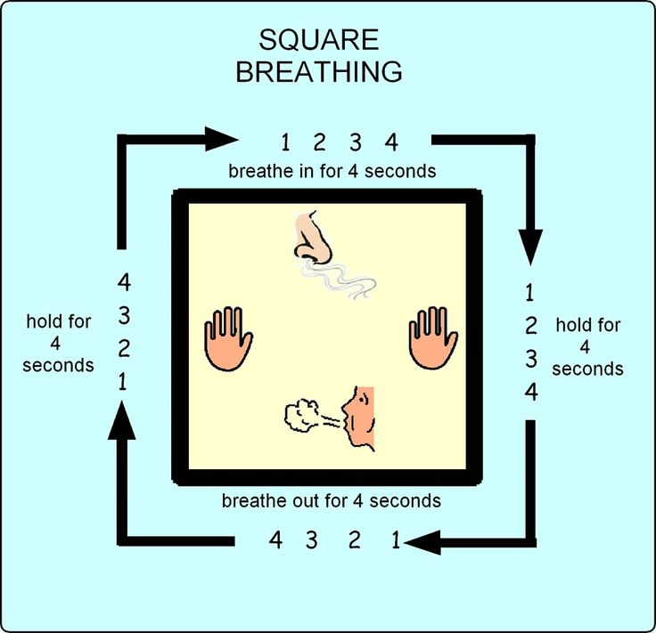
Square Breathing Visual From The Geneva Centre For Autism

