Keep Working!!

All the kids are working.

They are paying attention to the teacher. They are raising their hand to answer a question. The kids are working hard today.

The teacher is teaching. The students are listening. When everyone is quiet and watches and listens to the teacher, students can learn a lot in school.
These kids are working together. They are concentrating on their work. They want to follow the teacher’s directions.
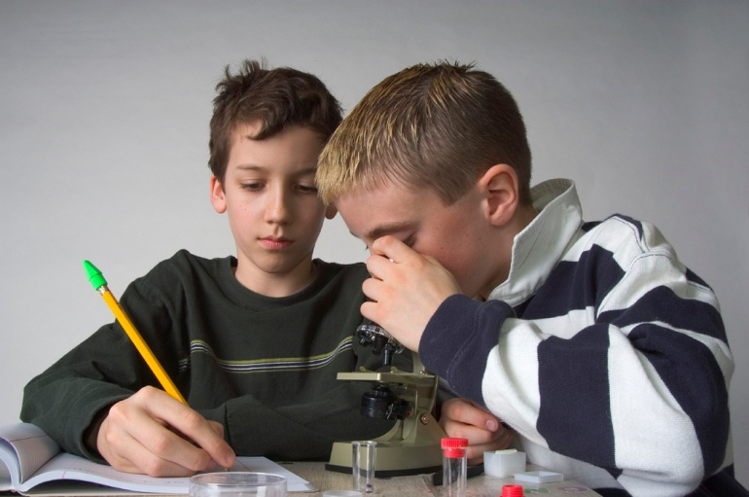
It is important to stay focused on what the teacher is saying. When you listen and stay focused on the teacher, you will learn a lot at school.

Sometimes kids try to distract each other when they should be listening to the teacher. Which of these students is trying to distract someone?
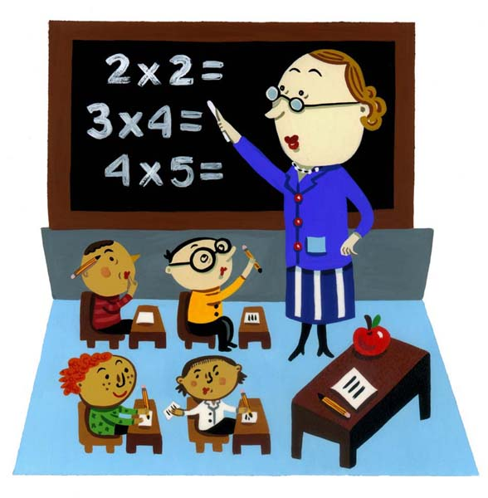

Is this boy focused on the teacher?

Do you think these children are focused on the teacher?
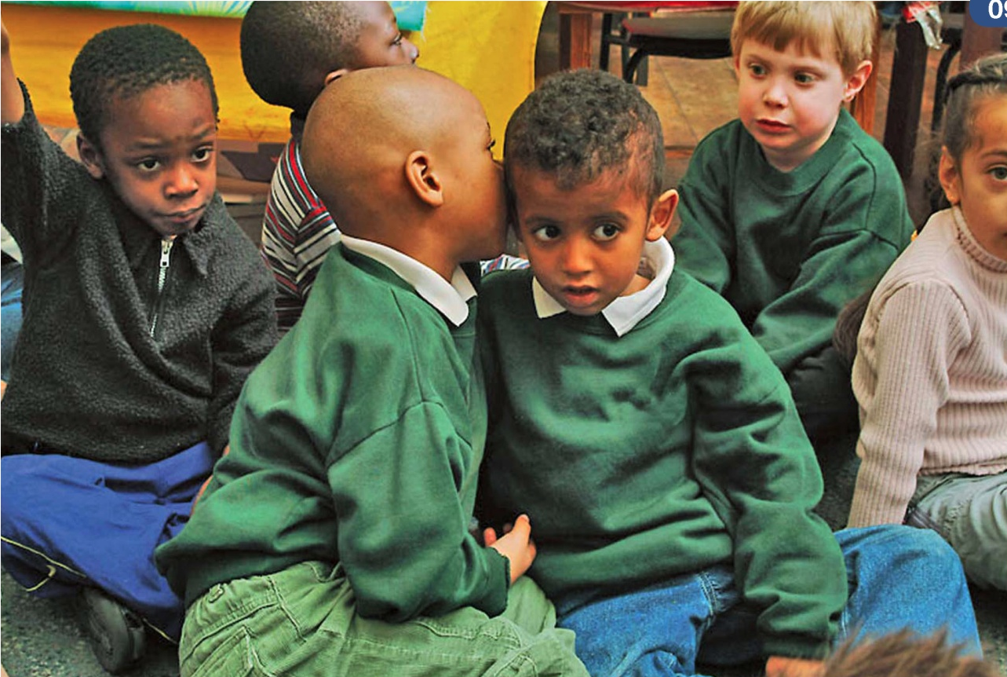
Being focused on the teacher means looking and listening to the teacher and doing your work.

So, let’s try to stay focused. Let’s try not to distract our friends. Then we’ll learn a lot in school every day.

