What Kids Expect – and What They Don’t Expect
Personal Space and Rules

In school, there are many kids in classes. Kids go to school ‘expecting’ their classmates to act a certain way.

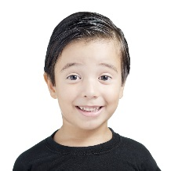
They expect kids to
smile

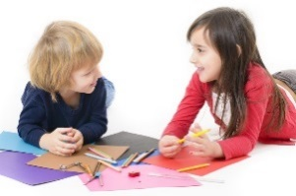
They expect kids to make conversation about things they might be interested in

They expect kids to keep ‘personal space’ and not get too close to them.
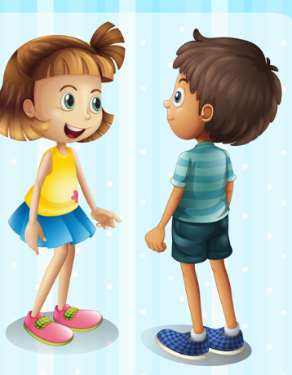

Some things kids DO NOT EXPECT (that is called UNEXPECTED BEHAVIORS) are:

A kid telling them rules all the time.
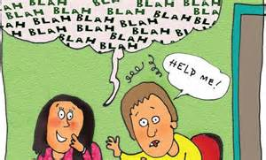

AHHHH.._______ is driving me crazy telling everybody the rules!!!!
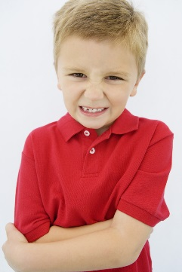

Kids DO NOT EXPECT a kid to get too close or touch them when they talk.
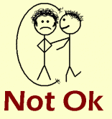
Get away from me! This does not feel good!

If you do UNEXPECTED things to kids then bad things can happen. They might think weird things about you.
Ahhh telling me the rules and getting too close to me is just weird!

They might hurt you and you might hurt back. They might yell at you and you might yell too. They might tell an adult about you.
Then you might miss recess.

But if you do what IS EXPECTED –
- Let the teachers tell the rules NOT YOU.
- Talk to kids without touching them.
- Walk away and tell adult if you are upset
Then
- you will have friends.
- you will keep your recess.
- your teacher might let you do other things that you like.

