My name is _____. I go to ______ School. I do really well in school.
Sometimes I feel itchy in my clothes.

Sometimes my pants feel funny and I want to fix them.
My pants feel funny, I want to fix them

Sometimes I just feel like putting my hand in my pants.

But, when I do that then my shirt goes up! That is not good to do in school.
In school if I need to fix my pants or itch then I can go to the girl’s bathroom.
I can just tell Ms. ________ that I have to go in the bathroom. She will say
“OK _____.”

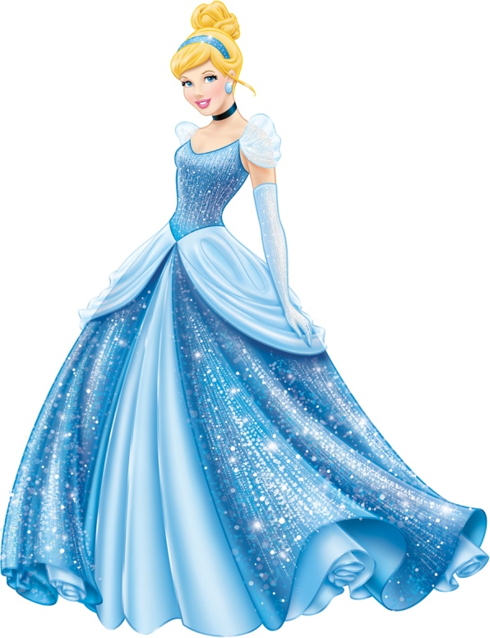
Princesses sometimes want to put their hand in their pants too but they ALWAYS wait until they are in the bathroom.
[name], you can do it – remember hands out of pants. But if you want to put your hands in pants – say: “May I go to the bathroom?”
[name], sometimes I have to put my hands in this long dress to scratch. I ALWAYS go to the bathroom to do that

