**LAUGH IT UP!**

**ACTIVITY: I CAN HANDLE EMBARRASSMENT**



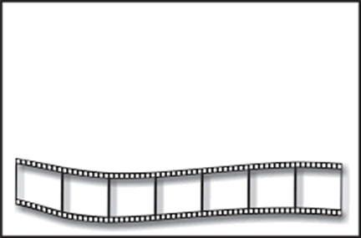

**DIRECTIONS: Pre-select a number of video clips from America’s Funniest Videos (**[**www.youtube.com**](http://www.youtube.com)**) that show embarrassing moments. Play the video clips one at a time, stopping between each one for discussion. Talk with the students about how the person in the video might have felt after the embarrassing moment. Then discuss possible ways that person could have handled the situation, using the 4 Ways to Handle Embarrassment from the social skills lesson.**