What’s Happening Today?

Let’s Talk About Ways to Handle Embarrassment

- Everyone has done or said something that made them look silly in front of others

- When we’re embarrassed it affects our body. We might sweat or blush. Our heart might race…

- It also affects the way we feel (self-conscious, ashamed, like we want to hide)

- There are 4 Ways to Handle Embarrassment:

- stop beating yourself up
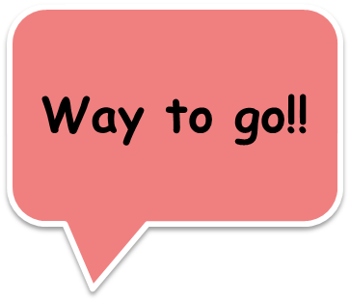
- laugh at yourself
- change the subject
- move forward

- So what do YOU think?

- Get your magnet!

