Social Skills – Teacher Note

Your student just completed a social skills lesson. The topic was:
I Can Handle Embarrassment. Your knowledge of this lesson may help you to help your student generalize the skills to other environments.

What he/she learned:

- We’ve all said or done something that makes us embarrassed.

- Embarrassment affects your body (i.e. blushing, sweating, racing heart, etc.) as well as how we feel (i.e. self-conscious, ashamed, like you want to hide) These feelings make it hard to know what to do next.

- There are 4 Ways to Handle Embarrassment:

- stop beating yourself up
- laugh at yourself
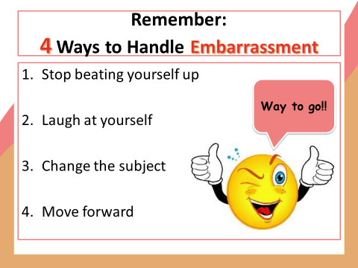
- change the subject
- move forward

- So what do YOU think?

Your student received a Lesson Summary magnet:

If you have a moment, email _____________________________ with any information that might help your student for the next lesson on ________________________. THANK YOU!!

