This week I might try:

To make good choices at school

I’ll try to remember that there are 3 ways to help me make good choices.

I can keep track of what I’m learning on the chart below:
I can try to make good choices at school if I remember to: | Day  1 | Day  2 | Day  3 | Day  4 | Day  5
- Be Kind

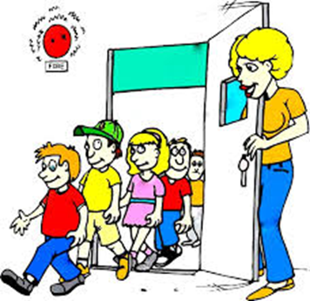
- Be Safe

- Be Responsible

I am accountable for what I say and do!

