This week I might try:

To show what I know when I gotta go (to the bathroom)

I’ll try to remember that there are 4 rules to keep me safe and clean in the bathroom.

I can keep track of what I’m learning on the chart below:
My School Bathroom Rules: | Day  1 | Day  2 | Day  3 | Day  4 | Day  5
- Take care of myself
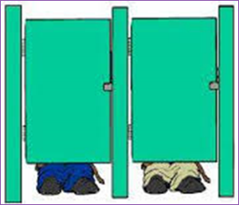
- Respect others

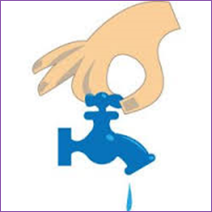
- Respect bathroom property

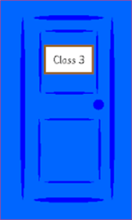
- Get back to class

