What’s Happening Today?

Let’s Talk About Showing What We Know
When We Gotta Go (to the Bathroom)

- There’s a right way to use the bathroom at school to keep us safe, healthy – and out of trouble!

- We might need to do different things before we leave the classroom – like raise our hands to ask permission, use a secret signal, get the bathroom pass, sign out, etc.

- Let’s look at some pictures of bathrooms. Which one would you rather go in?

- 4 School Bathroom Rules

- Take care of myself
- Respect others
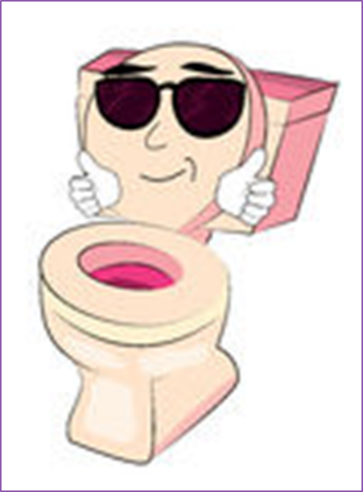
- Respect bathroom property
- Get back to class

- Can you remember all 4 rules?

- So what do YOU think?

- Get your magnet

