Social Skills – Parent Note

Your child just completed a social skills lesson. The topic was:
I Can Stay Safe on the School Bus. Your knowledge of this lesson may help you to help your child generalize the skills to other environments.

What he/she learned:

- There are different ways of getting to school (i.e. walking, riding in a car, riding a school bus) but each way has its own safety rules

- Even if a student doesn’t typically get to school by bus, at some point, he or she might ride a bus for a field trip, so it’s important to learn school bus safety rules, just like we learn rules to keep us safe at school

- 5 School Bus Safety Rules:

- Talk quietly
- Stay in your seat
- Don’t put anything out of the window
- Keep the aisle clear
- Wait for the bus to stop before getting up

- Children looked at different photos and identified those who were staying safe on the school bus and those who were not, using the above rules as guidelines

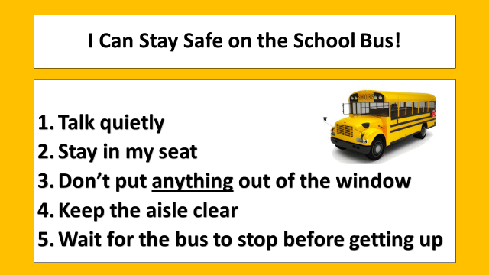
- So what do YOU think?

Your child received a Lesson Summary magnet:

If you have a moment, email _____________________________ with any information that might help your child for the next lesson on ________________________. THANK YOU!!

