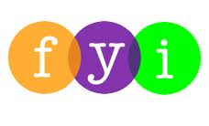
Social Skills –Parent Note

Your child just completed a social skills lesson. The topic was:
Am I a Bully?. Your knowledge of this lesson may help you to help your child generalize the skills to other environments.

What he/she learned:
- What is a bully? (review)

- There are different types of bullying (name calling, laughing at someone, leaving someone out, ignoring someone, tripping someone, unfriendly teasing, etc.)

- Sometimes people don’t realize that they’re bullying someone. They may have a hard time thinking about how others feel. They may also say or do whatever pops into their heads.

- Students took a quick bully quiz to find out if they may be bullying someone

- Students learned 3 Steps to Stop Being a Bully:

- Close your eyes and think back to when someone hurt you. How did it feel?
- Now think about your behavior towards someone else (what you did, who you hurt, why it hurt – was it helpful or harmful?)
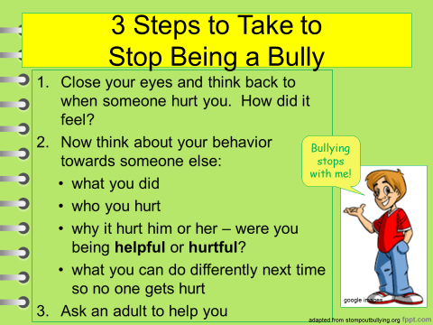
- Ask an adult to help you

- So what do YOU think?

Your child received a Lesson Summary magnet:

If you have a moment, email _____________________________ with any information that might help your child for the next lesson on ________________________. THANK YOU!!

