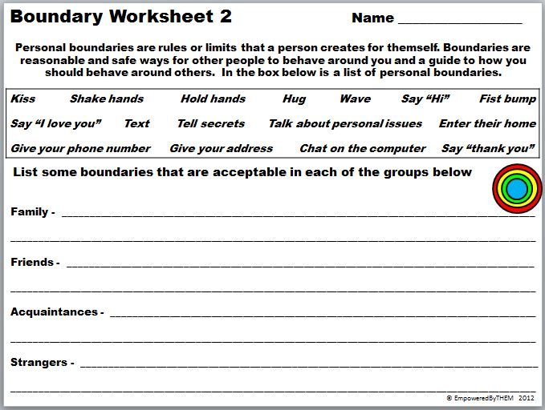

empoweredbythemblogspot.com

**HOMEWORK: I UNDERSTAND PERSONAL SPACE**