Going on a Field Trip to Soergel’s Farm
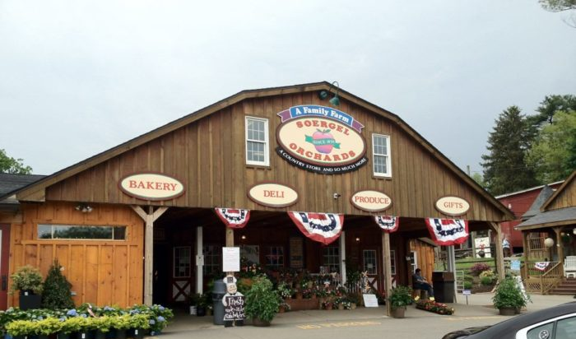

I am going on a field trip with my class to Soergel’s Farm.
It will be so much fun!!!
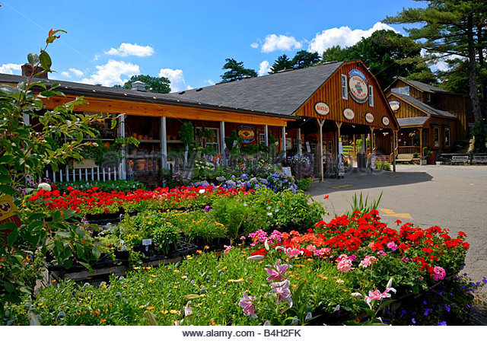
Soergel’s Farm has apple orchards, farm animals and beautiful flowers. They grow vegetables, fruits and all sorts of plants.
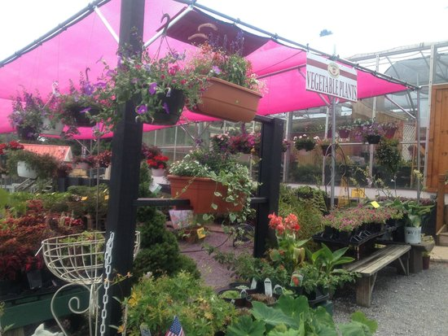
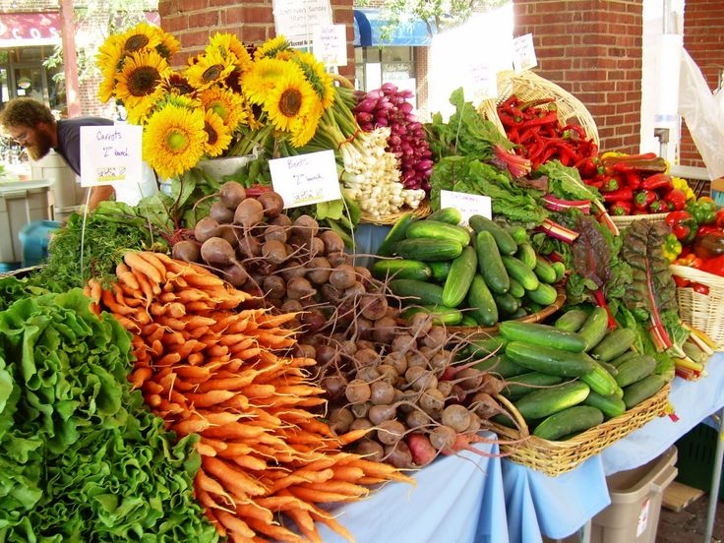

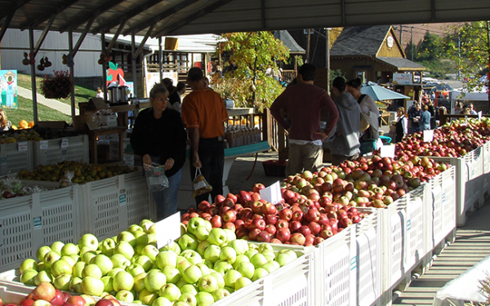
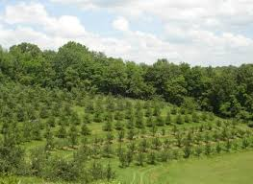

A school bus will come to _______ School and take us to Soergel’s. When it is time to leave Soergel’s, the school bus will take us back to ________ Elementary School.
Go to Soergel’s Farm
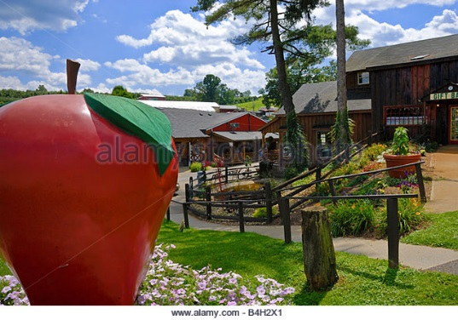
Have lots of fun at Soergel’s.
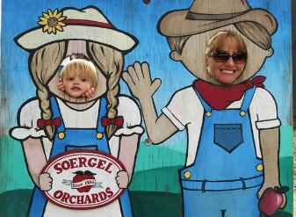
Go back to______ School [Pix of student’s school entry]
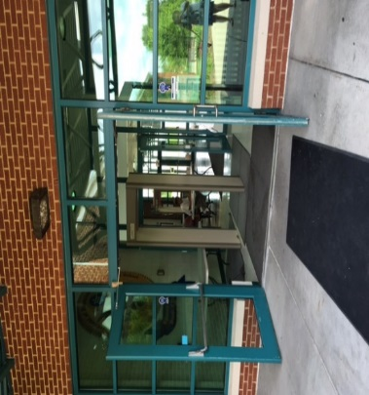

There are rules for staying safe on the bus and at Soergel’s Farm. These are the rules for going on any field trip. The rules are very easy and simple, but very important to stay safe and have fun.
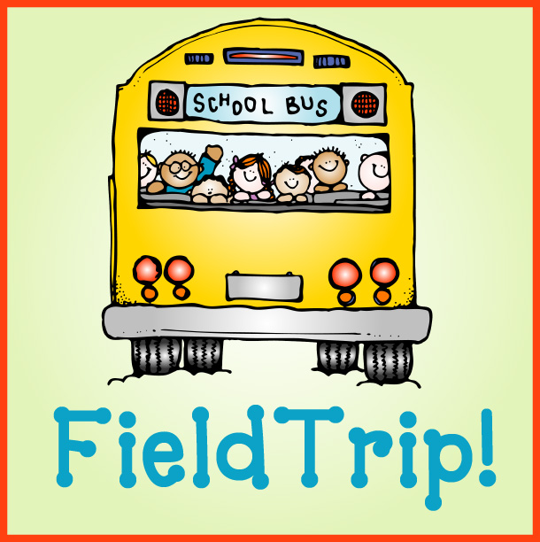
1. Always sit on the bus and never yell or scream.
2. Always stay with the teachers and classmates – never ever walk away from them.
3. Listen to your teachers and leaders. Follow their directions.
4. Ask your teacher for help if you need it.
5. Follow the rules for the place you are visiting.
6. Be nice to your friends and take turns.
7. Have fun!!!!!!!

When I get to Soergel’s I will be doing different activities. My teachers do not know which things we will do first, second, third or even last. The nice people from Soergel’s will tell us what we will do when we get there. Sometimes things may change or happen a little different from what they say, but that is okay.

My friends and my teachers are with me and we will still have fun.

[put in student’s favorite character here]

Here are some of the things I will be doing at Soergel’s with my class. I will remember that this is not the order or schedule. This is just a list of the fun things we may be doing.
Plant Sunflowers
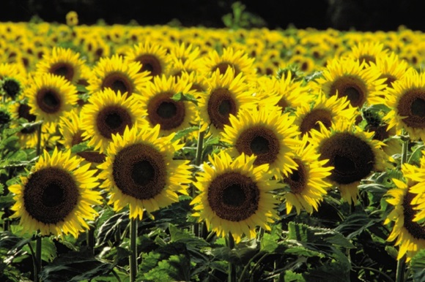

Go To the Apple Room
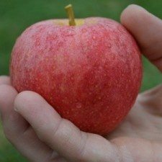

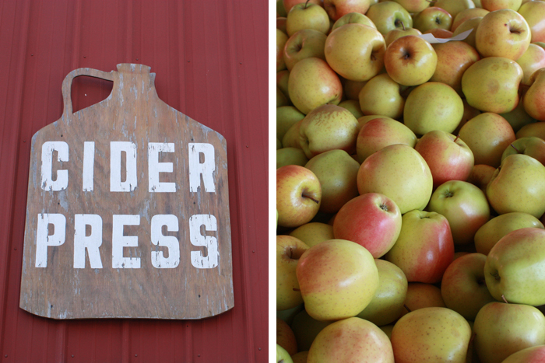See the Cider Press

Visit the Orchard
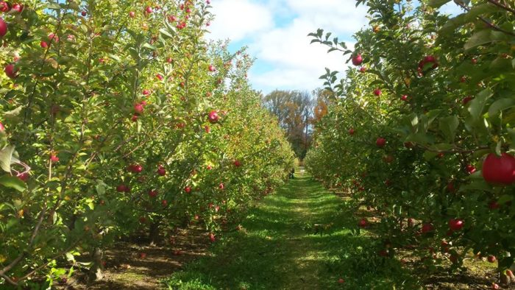

See the Bee Room
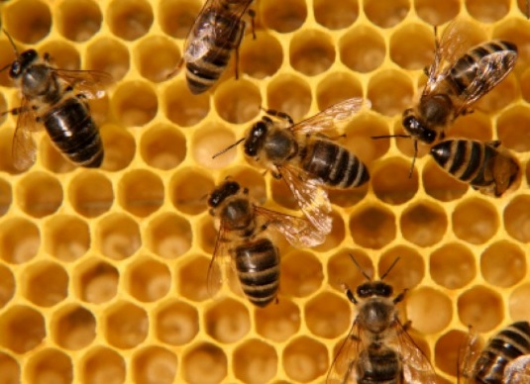
Visit the Farm Animals
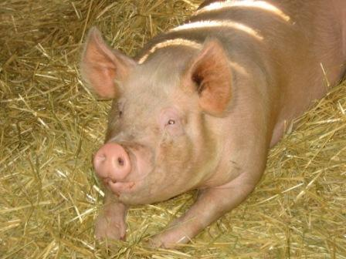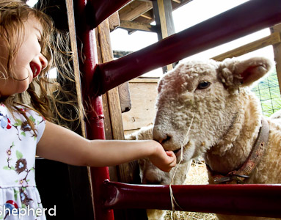
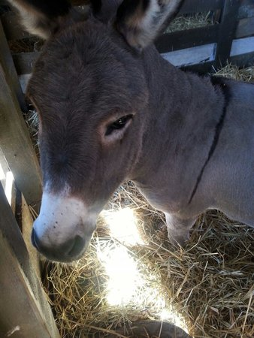
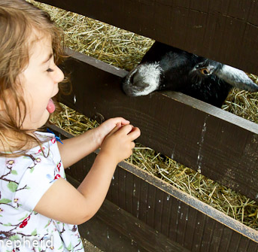

Soergel’s Farm looks like a fun place to visit.
I will have a great time on the field trip!
I can’t wait to go there so I can see and do so many awesome
things!!!!!

