**MOVING TO A NEW HOUSE**

I am moving to a new house. I feel lots of different ways about it. I might feel sad. I might feel scared. I might feel happy.

Insert facial expression of SIA character **Happy**

Insert appropriate facial expression of **scared** of child’s Special Interest Area (SIA) – (example –Spongebob)

Insert appropriate facial expression of **sad** of child’s Special Interest Area (SIA) – (example –Spongebob)

[](http://images.google.com/imgres?imgurl=http://chir.ag/calm-down/calm-down-intro.jpg&imgrefurl=http://chir.ag/calm-down/0&usg=__8FTkeuL7LmhZf0Qw-GDwUGet9Yk=&h=600&w=800&sz=88&hl=en&start=2&tbnid=mWKs2xMHuaSeGM:&tbnh=107&tbnw=143&prev=/images?q%3Dcalm%2Bdown%26gbv%3D2%26hl%3Den)It is okay to let myself feel all these things because I will still be safe. Even though some things will change, some things will stay the same too.

**It is okay to feel the way I do.**

I will still have my family.

I will make friends at my new school. They can come to my new house.

I will miss my old friends and school but **it is okay to feel the way I do.**

I will still get to eat my favorite foods!

[](http://images.google.com/imgres?imgurl=http://www.igda.org/huntsville/pizza-page.jpg&imgrefurl=http://www.igda.org/huntsville/archives/2007/aug/index.html&usg=__TG3O2u7x-s9rwE8OxEkOC6yQY-U=&h=704&w=803&sz=36&hl=en&start=1&tbnid=JwNmPCnhYAgJ1M:&tbnh=125&tbnw=143&prev=/images?q%3Dpizza%26gbv%3D2%26hl%3Den)

[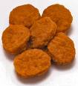](http://images.google.com/imgres?imgurl=http://www.betterschoolfood.org/media/newsletters/080929_files/visual_editor_preview_data_002/75.jpg&imgrefurl=http://www.betterschoolfood.org/media/newsletters/080929_files/visual_editor_preview_002.html&usg=__NKKg9rbNFAf1H4i55dWDvzjEytI=&h=289&w=264&sz=9&hl=en&start=2&tbnid=YnLvq6yyfMxcpM:&tbnh=115&tbnw=105&prev=/images?q%3Dchicken%2Bnuggets%26gbv%3D2%26hl%3Den)

Paste child’s favorite foods

I will still get to watch my favorite show!

**[INSERT IMAGES OF CHILD’S FAVORITE TV SHOW]**

I will still be able to use the computer!

[](http://images.google.com/imgres?imgurl=http://www.hudsonlibrary.org/Hudson%20Website/Computer%20Lab/MPj04100840000%5b1%5d.jpg&imgrefurl=http://www.hudsonlibrary.org/Hudson%20Website/Computer%20Lab/complab.htm&usg=__A90Ujs5ruEDSKcMqWFs1NAtYWms=&h=1024&w=965&sz=84&hl=en&start=8&tbnid=4LD4vNRi1acYyM:&tbnh=150&tbnw=141&prev=/images?q%3Dcomputer%26gbv%3D2%26hl%3Den)

**It is okay to feel the way I do.**

I will still be able to go to my favorite place.

**[Insert Child’s favorite place to visit]**

[](http://images.google.com/imgres?imgurl=http://www.kombo.com/images/content/news/blurb_gamestop_20081001.jpg&imgrefurl=http://www.kombo.com/article.php?artid%3D11825&usg=__47A_gaok_DMmXQExuDYRa-aEQfg=&h=344&w=443&sz=33&hl=en&start=2&tbnid=PufaX4eiRLEmqM:&tbnh=99&tbnw=127&prev=/images?q%3Dgamestop%26gbv%3D2%26hl%3Den) [](http://images.google.com/imgres?imgurl=http://news.softpedia.com/images/news2/GameStop-Slashes-Price-of-PSP-Giga-Pack-2.gif&imgrefurl=http://news.softpedia.com/news/GameStop-Slashes-Price-of-PSP-Giga-Pack-19172.shtml&usg=__AkpW3L6hJwqHoPhOCHaDptwsXHk=&h=250&w=250&sz=7&hl=en&start=13&tbnid=02a5Ep99nSFpKM:&tbnh=111&tbnw=111&prev=/images?q%3Dgamestop%26gbv%3D2%26hl%3Den)

I will still have my dreams! **[INSERT Child’s favorite ‘dreams’]**

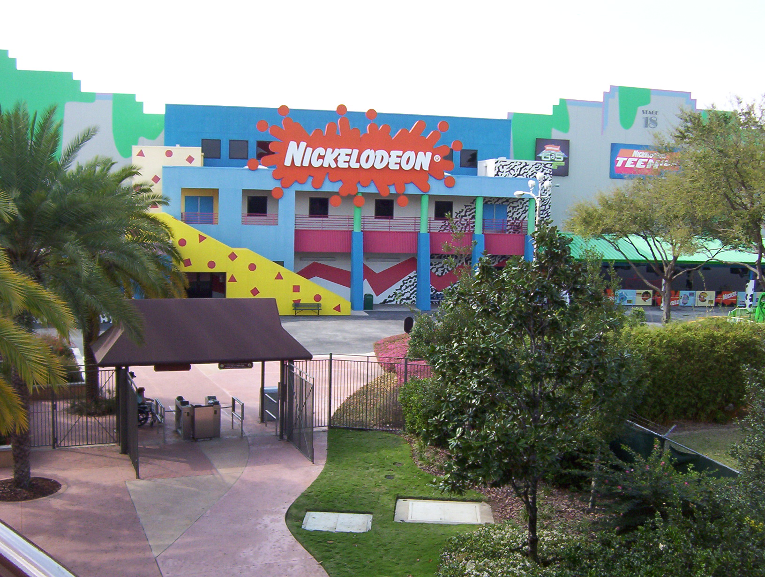

**It is okay to feel the way I do.**

It’s okay to feel sad or scared but when I start to feel **SAD** I can think about all the things that make me feel happy and safe.

I can think about all the things that stayed the same even though I moved to a new house.

[](http://images.google.com/imgres?imgurl=http://www.igda.org/huntsville/pizza-page.jpg&imgrefurl=http://www.igda.org/huntsville/archives/2007/aug/index.html&usg=__TG3O2u7x-s9rwE8OxEkOC6yQY-U=&h=704&w=803&sz=36&hl=en&start=1&tbnid=JwNmPCnhYAgJ1M:&tbnh=125&tbnw=143&prev=/images?q%3Dpizza%26gbv%3D2%26hl%3Den)[](http://images.google.com/imgres?imgurl=http://www.betterschoolfood.org/media/newsletters/080929_files/visual_editor_preview_data_002/75.jpg&imgrefurl=http://www.betterschoolfood.org/media/newsletters/080929_files/visual_editor_preview_002.html&usg=__NKKg9rbNFAf1H4i55dWDvzjEytI=&h=289&w=264&sz=9&hl=en&start=2&tbnid=YnLvq6yyfMxcpM:&tbnh=115&tbnw=105&prev=/images?q%3Dchicken%2Bnuggets%26gbv%3D2%26hl%3Den)

[](http://images.google.com/imgres?imgurl=http://news.softpedia.com/images/news2/GameStop-Slashes-Price-of-PSP-Giga-Pack-2.gif&imgrefurl=http://news.softpedia.com/news/GameStop-Slashes-Price-of-PSP-Giga-Pack-19172.shtml&usg=__AkpW3L6hJwqHoPhOCHaDptwsXHk=&h=250&w=250&sz=7&hl=en&start=13&tbnid=02a5Ep99nSFpKM:&tbnh=111&tbnw=111&prev=/images?q%3Dgamestop%26gbv%3D2%26hl%3Den)

[](http://images.google.com/imgres?imgurl=http://images1.fanpop.com/images/photos/1500000/Spongebob-spongebob-squarepants-1595658-1024-768.jpg&imgrefurl=http://www.fanpop.com/spots/spongebob-squarepants/images/1595658/title/spongebob&usg=__m36g2oZ4zLZi0yENU-2At9E56To=&h=768&w=1024&sz=653&hl=en&start=59&tbnid=lLh8oUc8gwktLM:&tbnh=113&tbnw=150&prev=/images?q%3Dspongebob%26gbv%3D2%26ndsp%3D20%26hl%3Den%26sa%3DN%26start%3D40)

**[INSERT Child’s favorite items above]**

I can do other things to make me feel good! **I can:**

Ask my Mom for a hug or squeezes.

Color in my Sponge Bob coloring book.

Draw a picture of my Sponge Bob [**INSERT your child’s SIA]** friends.

When I do these things, my Mom will feel better too.

**It is okay to feel the way I do.**

**[INSERT PIX of your child’s SIA]**

[](http://images.google.com/imgres?imgurl=http://www.nick.com.pl/img/33/198/_1600x1200/86_spongebob_1024x768.jpg&imgrefurl=http://www.vis.hk/index.php?page%3Dsearch/images%26search%3Dspongebob%26type%3Dimages&usg=__8HWz9hvwsuZmSgHRnD6gqKzvbys=&h=1200&w=1600&sz=1525&hl=en&start=62&tbnid=i1N0Xx7KgBlg3M:&tbnh=113&tbnw=150&prev=/images?q%3Dspongebob%26imgsz%3Dl%26imgtbs%3Dz%26gbv%3D2%26ndsp%3D18%26hl%3Den%26sa%3DN%26start%3D54)