What will we do at Heinz Field?
We are going to visit Heinz Field. Heinz field is a big giant field where they play football. The Pittsburgh Steelers play on this field.
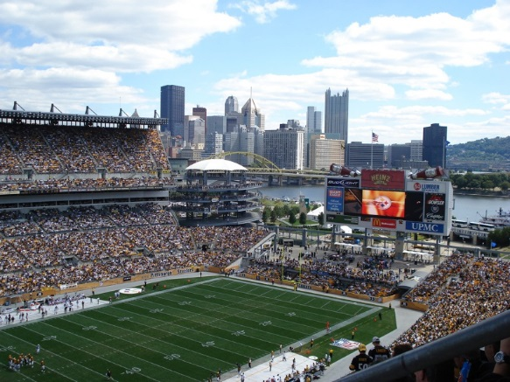

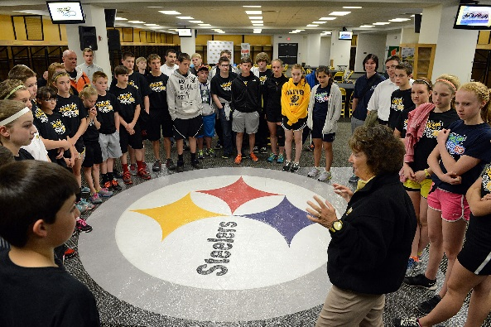
We will be walking with lots of kids. We will have a guide. That is a person who takes us around and talks to us.

We have to listen to the talking. We have to walk fast to keep up.

Some places we will go are:
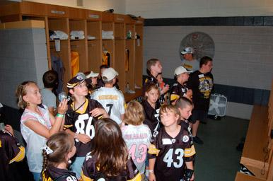
The locker room –

The Press Box – that is where radio and TV people talk about the games.
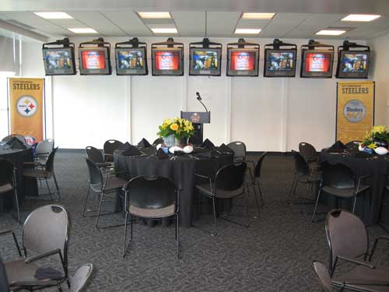
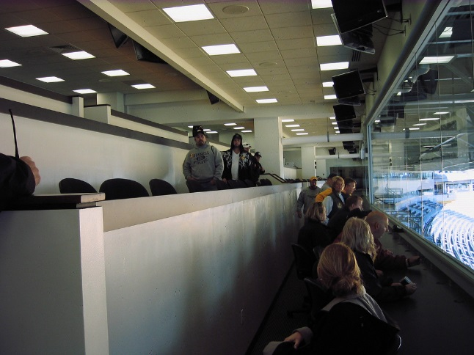

The Great Hall – This is like a giant museum of sports things. There is a gift shop there too.
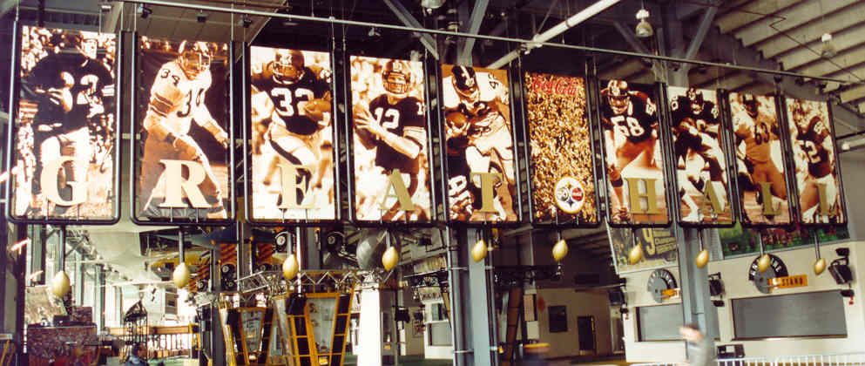
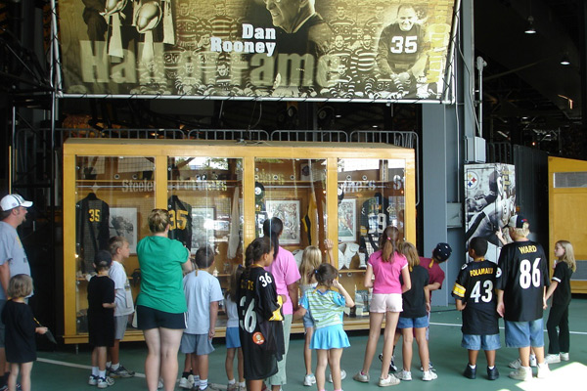
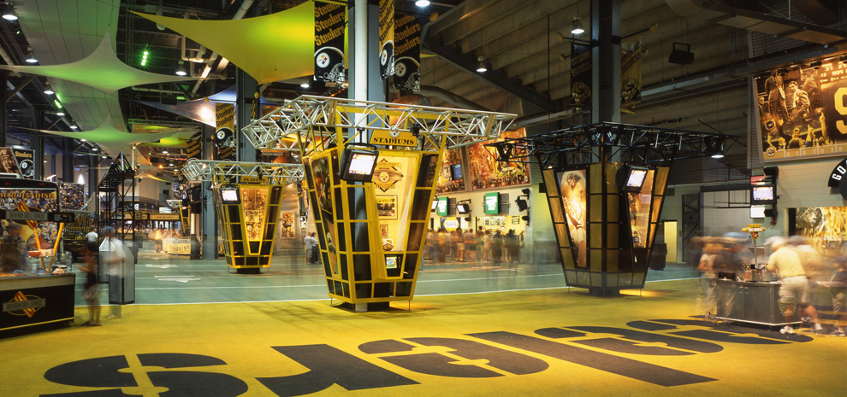
When When we are finished at Heinz Field then we go to the Science Center. I have been there. We get to go to the Omni Theatre!

That is a giant movie theatre with a giant screen.
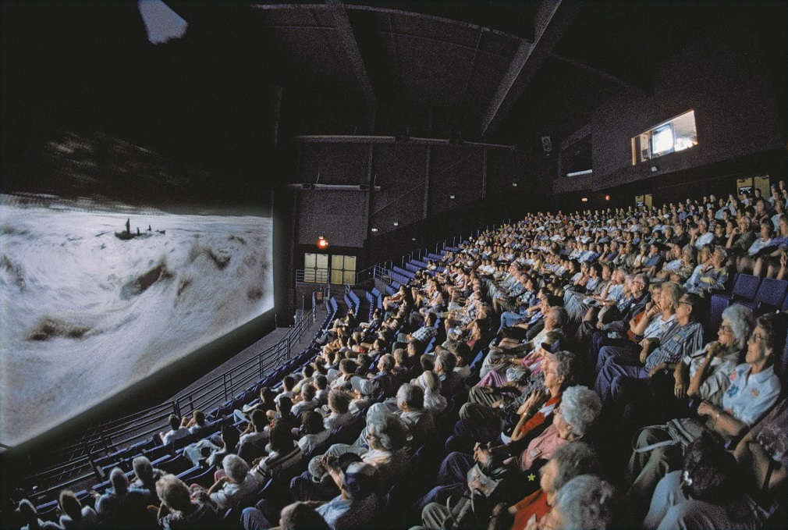

If I get tired I can use my words and say “I need to sit down.” OR “I need to leave now.”
If it is too loud I can use my words and say: “It is loud, I need my head set.” OR “It is loud, I need to leave.”
or I can hand my card to Ms. _____ or Ms. ______ or Ms. _____. They will help me.

